RESOLUTION 16-211

A RESOLUTION OF THE CITY OF WOODBURN, INDIANA
COMMON COUNCIL REGARDING
TRANSFERS OF MONEY WITHIN THE GENERAL FUND

WHEREAS, within the General Fund there is a line item that has become negative and a transfer is required as allowed by IC 6-1.1-18-6 with terminology as defined by the Accounting and Uniform Compliance Guidelines Manual for Cities and Towns:
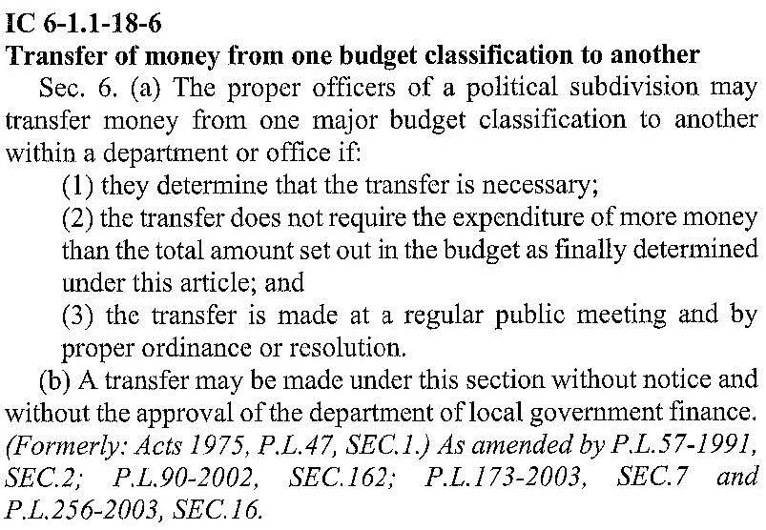
Major Budget Classification means one of the four major classifications of expenses for which
appropriations are made under the uniform budget system prescribed for cities and towns. The major classifications are: Personal Services; Supplies; Other Services and Charges; and Capital Outlay.

NOW THEREFORE, BE IT ORDAINED by the Common Council of the City of Woodburn, that $8.88 be deducted

from 101-002-000240 Major Classification: Supplies, Line Item: Other Supplies
into 101-002-000213 Major Classification: Supplies, Line Item: Office Supplies

This transfer will result in a balance of $0.00 for line item 101-002-000213

Adopted and Resolved this ________ day of ________________________, 2016.

COMMON COUNCIL OF THE CITY OF WOODBURN, INDIANA

By: ___________________________________
Daniel Watts, Councilman

By: ___________________________________
Mike Voirol, Councilman

By: ___________________________________
Dean Gerig, Councilman

By: ___________________________________
John Renner, Councilman

By: ___________________________________
Michael Martin, Councilman

ATTEST:

By: ______________________________________
Timothy Cummins, Clerk-Treasurer

The foregoing resolution passed by the Council is signed and approved ( ) / not approved ( ) by me on the same date.

By: ______________________________________
Joseph Kelsey, Mayor of the City of Woodburn

WAIVER OF SECOND READING
On motion duly made and seconded, the second reading of the foregoing Resolution was unanimously waived and the Resolution was deemed effective as of the date of passage.

COMMON COUNCIL OF THE CITY OF WOODBURN, INDIANA

By: ___________________________________
Daniel Watts, Councilman

By: ___________________________________
Mike Voirol, Councilman

By: ___________________________________
Dean Gerig, Councilman

By: ___________________________________
John Renner, Councilman

By: ___________________________________
Michael Martin, Councilman

ATTEST:

By: ______________________________________
Timothy Cummins, Clerk-Treasurer

