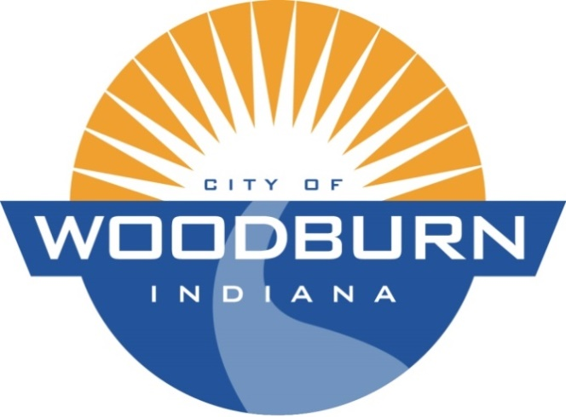

Board of Works and Public Safety:
Commencing at 5:30pm under the direction of Mayor Joseph Kelsey
Board Members: Kevin Heckley, Mark Hoeppner

Police Chief: Brad Parker

Superintendent: Ryan Walls

Clerk-Treasurer/Secretary: Timothy Cummins

Old Business:
N/A

New Business:
- Review Quotes from Indiana Bond Bank and Tax Exempt Leasing for Street Sweeper Funding

THE AGENDA FOR THE BOARD OF WORKS AND PUBLIC SAFETY
AND
THE AGENDA FOR THE COMMON COUNCIL
FOR
MONDAY, NOVEMBER 16TH, 2020

Common Council:
Commencing at 7:00pm under the direction of Mayor Joseph Kelsey
Council Members: Michael Martin, Tonya Thompson, Dean Gerig, Daniel Watts, Michael Voirol

Police Chief: Brad Parker

Superintendent: Ryan Walls

Clerk-Treasurer/Secretary: Timothy Cummins

Old Business:
- Ord. 20-1391 (Re-Establish Garbage Rates for 2021-2023)
New Business:
- Public Hearing RE: 2021-2023 Garabage/Recycling Rates
- Presentation from Rob Peters w/Colonial Life
- Res. 20-253 (Appropriation Transfers and Reductions w/in Funds)
- Ord. 20-1393 (Modify Sewer Rates)

