RESOLUTION 16-214

A RESOLUTION OF THE CITY OF WOODBURN, INDIANA
COMMON COUNCIL REGARDING
TRANSFERS OF MONEY WITHIN MULTIPLE FUNDS

WHEREAS, within several funds there is at least one line item that requires additional monies for the 2016 calendar year and a transfer is required as allowed by IC 6-1.1-18-6
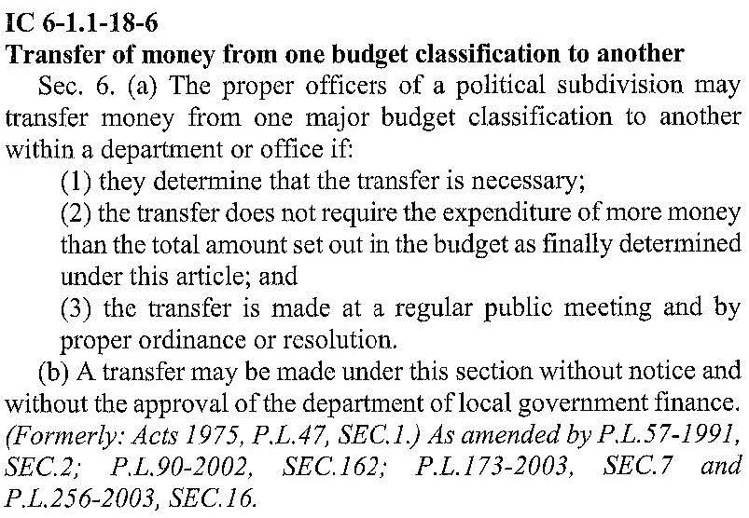
NOW THEREFORE, BE IT ORDAINED by the Common Council of the City of Woodburn, that within the GENERAL FUND, the following lines are debited as follows:
101-001-000340 Insurance Liability, in the amount of $9,900.00
101-001-000310 Professional Services, in the amount of $1,900.00
101-001-000384 Mayor Budget, in the amount of $2,000.00
101-001-000430 Computer Hard/Software, in the amount of $1,600.00
Total Debit: $15,400.00
And, within the GENERAL FUND, the following lines are credited as follows:
101-001-000123 Group Insurance, in the amount of $10,500.00
101-002-000126 PD Group Health Insurance, in the amount of $2,000.00
101-001-000124 Unemployment, in the amount of $400.00
101-001-000120 Fica 7.65%, in the amount of $2,400.00
101-002-000355 Electric Police Department, in the amount of $100.00
Total Credit: $15,400
This transfer will result in a net transfer of $0.00 within the GENERAL FUND

Regarding the MVH FUND, the following lines are debited as follows:
201-001-000398 Severn Trent Services, in the amount of $3,000.00
Total Debit: $3,000.00
And, within the MVH FUND, the following lines are credited as follows:
201-000-000120 Fica 7.65%, in the amount of $250.00
201-000-000242 Superintendent Wage, in the amount of $1,100.00
201-000-000243 Utility 1 Wage, in the amount of $1,100.00
201-000-000244 Utility 2 Wage, in the amount of $550.00
Total Credit: $3,000.00
This transfer will result in a net transfer of $0.00 within the MVH FUND

Regarding the EDIT FUND, the following lines are debited as follows:
444-001-000381 Loan Industrial Park, in the amount of $35,000.00
Total Debit: $35,000.00
And, within the EDIT FUND, the following lines are credited as follows:
444-000-000120 Fica 7.65%, in the amount of $500.00
444-000-000242 Superintendent Wage, in the amount of $2,200.00
444-000-000243 Utility 1 Wage, in the amount of $2,200.00
444-000-000244 Utility 2 Wage, in the amount of $1,100.00
444-001-000301 Professional Services, in the amount of $20,000.00
444-001-039901 Misc, in the amount of $9,000.00
Total Credit: $35,000.00
This transfer will result in a net transfer of $0.00 within the EDIT FUND

Adopted and Resolved this 21st day of November, 2016.

<SIGNATURES ON THE FOLLOWING PAGE>

WAIVER OF SECOND READING
On motion duly made and seconded, the second reading of the foregoing Resolution was unanimously waived and the Resolution was deemed effective as of the date of passage.

COMMON COUNCIL OF THE CITY OF WOODBURN, INDIANA

By: ___________________________________
Daniel Watts, Councilman

By: ___________________________________
Mike Voirol, Councilman

By: ___________________________________
Dean Gerig, Councilman

By: ___________________________________
John Renner, Councilman

By: ___________________________________
Michael Martin, Councilman

ATTEST:

By: ______________________________________
Timothy Cummins, Clerk-Treasurer

COMMON COUNCIL OF THE CITY OF WOODBURN, INDIANA

By: ___________________________________
Daniel Watts, Councilman

By: ___________________________________
Mike Voirol, Councilman

By: ___________________________________
Dean Gerig, Councilman

By: ___________________________________
John Renner, Councilman

By: ___________________________________
Michael Martin, Councilman

ATTEST:

By: ______________________________________
Timothy Cummins, Clerk-Treasurer

The foregoing resolution passed by the Council is signed and approved ( ) / not approved ( ) by me on the same date.

By: ______________________________________
Joseph Kelsey, Mayor of the City of Woodburn

