RESOLUTION 17-215

A RESOLUTION OF THE CITY OF WOODBURN, INDIANA
COMMON COUNCIL REGARDING
TRANSFERS OF MONEY WITHIN THE EDIT FUND

WHEREAS, within the EDIT Fund there is a line item that requires additional monies for the 2017 calendar year and a transfer is required as allowed by IC 6-1.1-18-6
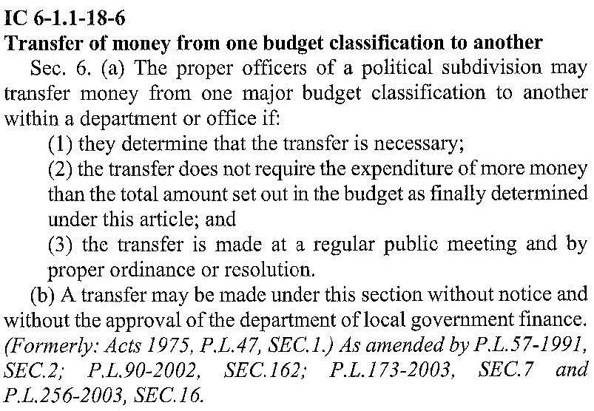
NOW THEREFORE, BE IT ORDAINED by the Common Council of the City of Woodburn,

that within the EDIT FUND, the following line is debited as follows:
444-001-000301 Professional Services, in the amount of $15,042.36
Total Debit: $15,042.36
And, within the EDIT FUND, the following line is credited as follows:
444-000-000127 IPEP Safety Grant, in the amount of $15,042.36
Total Credit: $15,042.36

This transfer will result in a net transfer of $0.00 within the EDIT FUND

Adopted and Resolved this 6th day of February, 2017.
WAIVER OF SECOND READING
On motion duly made and seconded, the second reading of the foregoing Resolution was unanimously waived and the Resolution was deemed effective as of the date of passage.

COMMON COUNCIL OF THE CITY OF WOODBURN, INDIANA

By: ___________________________________
Daniel Watts, Councilman

By: ___________________________________
Mike Voirol, Councilman

By: ___________________________________
Dean Gerig, Councilman

By: ___________________________________
John Renner, Councilman

By: ___________________________________
Michael Martin, Councilman

ATTEST:

By: ______________________________________
Timothy Cummins, Clerk-Treasurer

COMMON COUNCIL OF THE CITY OF WOODBURN, INDIANA

By: ___________________________________
Daniel Watts, Councilman

By: ___________________________________
Mike Voirol, Councilman

By: ___________________________________
Dean Gerig, Councilman

By: ___________________________________
John Renner, Councilman

By: ___________________________________
Michael Martin, Councilman

ATTEST:

By: ______________________________________
Timothy Cummins, Clerk-Treasurer

The foregoing resolution passed by the Council is signed and approved ( ) / not approved ( ) by me on the same date.

By: ______________________________________
Joseph Kelsey, Mayor of the City of Woodburn

