RESOLUTION 19-240
A RESOLUTION OF THE CITY OF WOODBURN, INDIANA
COMMON COUNCIL REGARDING
TRANSFERS OF APPROPRIATIONS WITHIN MULTIPLE FUNDS AS WELL AS A TRANSFER BETWEEN FUNDS

WHEREAS, within multiple funds there are line items that require additional monies allocated for the 2019 calendar year and a transfer of appropriation is required as allowed by IC 6-1.1-18-6;
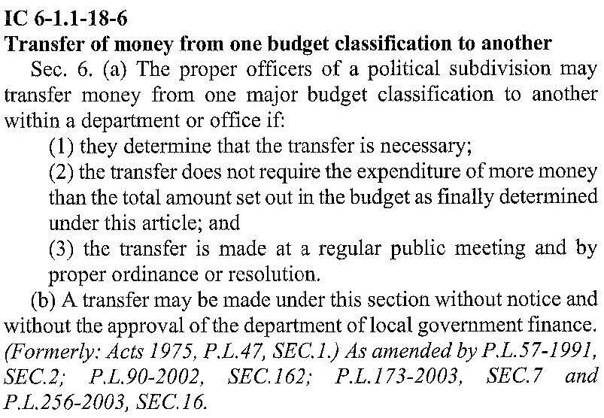
NOW THEREFORE, BE IT RESOLVED by the Common Council of the City of Woodburn:

That within the GENERAL FUND, the following lines are debited as described:
101-001-000351 ELECTRIC TILE MILL, in the amount of $2,000.00
101-002-000220 AMMUNITION, in the amount of $3,000.00
101-002-000221 FUEL POLICE DEPARTMENT, in the amount of $4,000.00
101-002-000320 CELL PHONE/AIR CARDS, in the amount of $1,000.00
Total Debit: $10,000.00
And, within the GENERAL FUND, the following lines are credited as described:
101-001-000350 ELECTRIC CITY HALL, in the amount of $250.00
101-001-000361 MAIN.OF BUILDINGS, in the amount of $500.00
101-001-000390 ASSN. DUES/SEMINARS, in the amount of $250.00
101-001-000393 PROMOTIONS, in the amount of $1,000.00
101-001-000442 IT SERVICES, in the amount of $1,500.00
101-002-000213 OFFICE SUPPLIES, in the amount of $250.00
101-002-000223 UNIFORMS, in the amount of $500.00
101-002-000240 OTHER SUPPLIES, in the amount of $1,000.00
101-002-000355 ELECTRIC POLICE, in the amount of $500.00
101-002-000356 GAS POLICE DEPARTMENT, in the amount of $500.00
101-002-000363 REPAIRS AND MAIN., in the amount of $250.00
101-002-000394 PROMOTIONS, in the amount of $500.00
101-002-000397 OTHER EQUIPMENT, in the amount of $3,000.00
Total Credit: $10,000.00
This appropriation transfer will result in a net transfer of $0.00 within the GENERAL FUND.

That within the COIT PUBLIC SAFETY FUND, the following lines are debited as described:
247-000-000313 LEGAL FEES POLICE, in the amount of $1,000.00
Total Debit: $1,000.00
And, within the COIT PUBLIC SAFETY FUND, the following lines are credited as described:
247-000-000135 PD MISC, in the amount of $1,000.00
Total Credit: $1,000.00
This appropriation transfer will result in a net transfer of $0.00 within the COIT PUBLIC SAFETY FUND.

That within the EDIT FUND, the following lines are debited as described:
444-001-999998 STELLAR COMMUNITY, in the amount of $15,500.00
Total Debit: $15,500.00
And, within the EDIT FUND, the following lines are credited as described:
444-000-000382 PD/UTILITY VEHICLE, in the amount of $500.00
444-001-000301 PROFESSIONAL SERVICES, in the amount of $5,000.00
444-001-039901 MISC, in the amount of $10,000.00
Total Credit: $15,500.00
This appropriation transfer will result in a net transfer of $0.00 within the EDIT FUND.

That $10,705.36 be transferred from Fund 223, MAIN ST GRANT, into Fund 222, MAIN ST SUSTAINABILITY.

Adopted and Resolved this 4th day of November, 2019.

COMMON COUNCIL OF THE CITY OF WOODBURN, INDIANA

By: ___________________________________ YEA_____ NAY_____ ABS_____
Daniel Watts, Councilman

By: ___________________________________ YEA_____ NAY_____ ABS_____
Mike Voirol, Councilman

By: ___________________________________ YEA_____ NAY_____ ABS_____
Dean Gerig, Councilman

By: ___________________________________ YEA_____ NAY_____ ABS_____
John Renner, Councilman

By: ___________________________________ YEA_____ NAY_____ ABS_____
Michael Martin, Councilman

ATTEST:

By: ______________________________________
Timothy Cummins, Clerk-Treasurer

The foregoing resolution passed by the Council is signed and approved ( ) / not approved ( ) by me on the same date.

By: ______________________________________
Joseph Kelsey, Mayor of the City of Woodburn

