RESOLUTION 19-241
A RESOLUTION OF THE CITY OF WOODBURN, INDIANA
COMMON COUNCIL REGARDING
TRANSFERS OF APPROPRIATIONS WITHIN MULTIPLE FUNDS

WHEREAS, within multiple funds there are line items that require additional monies allocated for the 2019 calendar year and a transfer of appropriation is required as allowed by IC 6-1.1-18-6;
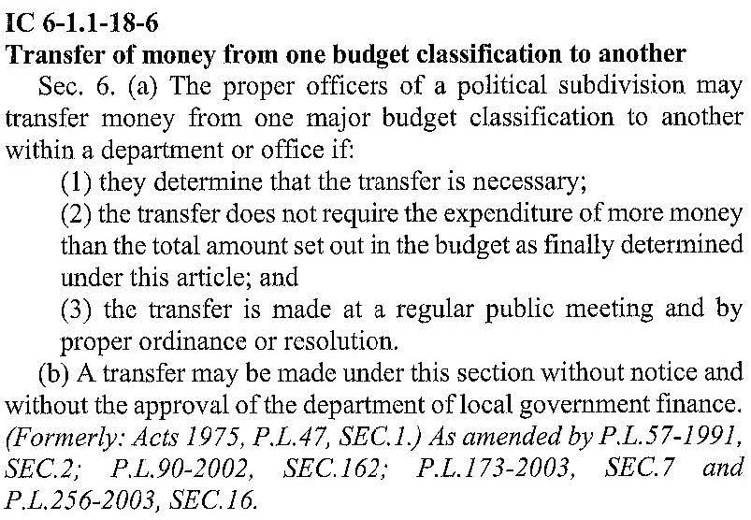
NOW THEREFORE, BE IT RESOLVED by the Common Council of the City of Woodburn:

That within the GENERAL FUND, the following line is debited as described:
101-001-000351 ELECTRIC TILE MILL, in the amount of $4,000.00
Total Debit: $4,000.00
And, within the GENERAL FUND, the following lines are credited as described:
101-000-200000 TRANSFERS TO OTHER FUNDS, in the amount of $500.00
101-001-000211 OFFICE SUPPLIES, in the amount of $1,000.00
101-001-000393 PROMOTIONS, in the amount of $1,000.00
101-001-000430 COMPUTER HARDWARE/SOFTWARE, in the amount of $250.00
101-002-000340 INSURANCE LIABILITY, in the amount of $1,250.00
Total Credit: $4,000.00
This appropriation transfer will result in a net transfer of $0.00 within the GENERAL FUND.

That within the EDIT FUND, the following line is debited as described:
444-000-000131 CCG-ENGINEERING, in the amount of $10,000.00
Total Debit: $10,000.00
And, within the EDIT FUND, the following lines are credited as described:
444-001-000301 PROFESSIONAL SERVICES, in the amount of $10,000.00
Total Credit: $10,000.00
This appropriation transfer will result in a net transfer of $0.00 within the EDIT FUND.

Adopted and Resolved this 16th day of December, 2019.

< SIGNATURES ON THE FOLLOWING PAGE >

COMMON COUNCIL OF THE CITY OF WOODBURN, INDIANA

By: ___________________________________ YEA_____ NAY_____ ABS_____
Daniel Watts, Councilman

By: ___________________________________ YEA_____ NAY_____ ABS_____
Mike Voirol, Councilman

By: ___________________________________ YEA_____ NAY_____ ABS_____
Dean Gerig, Councilman

By: ___________________________________ YEA_____ NAY_____ ABS_____
John Renner, Councilman

By: ___________________________________ YEA_____ NAY_____ ABS_____
Michael Martin, Councilman

ATTEST:

By: ______________________________________
Timothy Cummins, Clerk-Treasurer

The foregoing resolution passed by the Council is signed and approved ( ) / not approved ( ) by me on the same date.

By: ______________________________________
Joseph Kelsey, Mayor of the City of Woodburn

