RESOLUTION 20-247
A RESOLUTION OF THE CITY OF WOODBURN, INDIANA
COMMON COUNCIL REGARDING
TRANSFERS OF APPROPRIATIONS WITHIN MULTIPLE FUNDS

WHEREAS, within multiple funds there are line items that require additional monies allocated for the 2020 calendar year and a transfer of appropriation is required as allowed by IC 6-1.1-18-6;
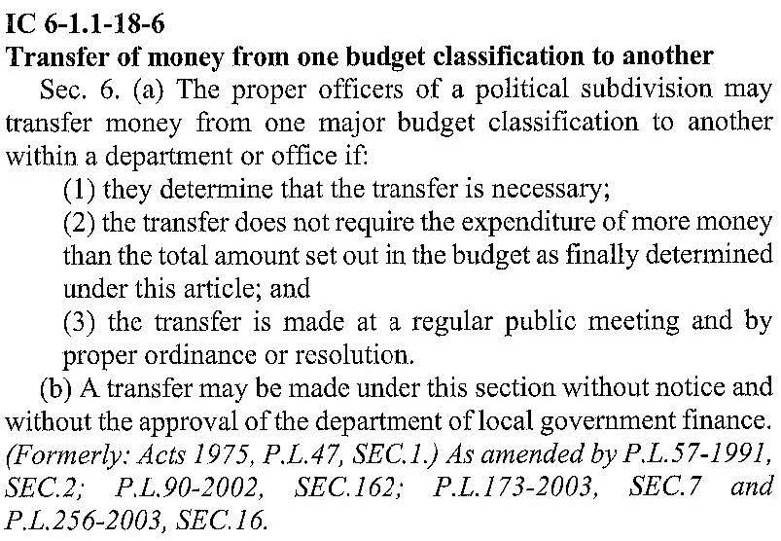
NOW THEREFORE, BE IT RESOLVED by the Common Council of the City of Woodburn:
That within the GENERAL FUND, the following lines are debited as described:
101-001-000120 FICA 7.65%, in the amount of $1,750.00
101-001-000351 ELECTRIC TILE MILL, in the amount of $1,000.00
101-001-000393 PROMOTIONS, in the amount of $1,500.00
101-001-000395 MISC, in the amount of $250.00
101-002-000220 AMMUNITION, in the amount of $1,500.00
101-002-000223 UNIFORMS, in the amount of $1,000.00
101-002-000363 REP. & MAIN., in the amount of $500.00
101-002-000397 OTHER EQUIPMENT, in the amount of $250.00
Total Debit: $7,750.00
And, within the GENERAL FUND, the following lines are credited as described:
101-000-000120 FICA 7.65%, in the amount of $1,750.00
101-001-000124 UNEMPLOYMENT, in the amount of $1,000.00
101-001-000211 OFFICE SUPPLIES, in the amount of $1,250.00
101-001-000353 GAS TILE MILL ROAD, in the amount of $250.00
101-002-000124 UNEMPLOYMENT, in the amount of $750.00
101-002-000213 OFFICE SUPPLIES, in the amount of $250.00
101-002-000230 VEHICLE REPAIRS, in the amount of $2,500.00
Total Credit: $7,750.00
This appropriation transfer will result in a net transfer of $0.00 within the GENERAL FUND.

That within the LOCAL ROAD AND STREET, the following line is debited as described:
202-000-000202 ROADSIDE SIGNAGE, in the amount of $3,000.00
Total Debit: $3,000.00
And, within the LOCAL ROAD AND STREET, the following line is credited as described:
202-000-000384 STREET AND SIDEWALK REPAIR, in the amount of $3,000.00
Total Credit: $3,000.00
This appropriation transfer will result in a net transfer of $0.00 within the LOCAL ROAD AND STREET.

That within the COIT PUBLIC SAFETY FUND, the following line is debited as described:
247-000-000136 PD TRAINING AND EQUIPMENT, in the amount of $5,000.00
Total Debit: $5,000.00
And, within the COIT PUBLIC SAFETY FUND, the following line is credited as described:
247-000-000135 PD MISC, in the amount of $5,000.00
Total Credit: $5,000.00
This appropriation transfer will result in a net transfer of $0.00 within the COIT PUBLIC SAFETY FUND.

That within the EDIT FUND, the following lines are debited as described:
444-000-000131 CCG-ENGINEERING, in the amount of $10,000.00
444-001-000301 PROFESSIONAL SERVICES, in the amount of $2,250.00
Total Debit: $12,500.00
And, within the EDIT FUND, the following lines are credited as described:
444-000-000400 WATER AND SEWER, in the amount of $2,250.00
444-001-039901 MISC, in the amount of $10,000.00
Total Credit: $12,500.00
This appropriation transfer will result in a net transfer of $0.00 within the EDIT FUND.

Adopted and Resolved this 15th day of June, 2020.
< SIGNATURES ON THE FOLLOWING PAGE >
COMMON COUNCIL OF THE CITY OF WOODBURN, INDIANA

By: ___________________________________ YEA_____ NAY_____ ABS_____
Michael Voirol, Councilman

By: ___________________________________ YEA_____ NAY_____ ABS_____
Michael Martin, Councilman

By: ___________________________________ YEA_____ NAY_____ ABS_____
Tonya Thompson, Councilman

By: ___________________________________ YEA_____ NAY_____ ABS_____
Dean Gerig, Councilman

By: ___________________________________ YEA_____ NAY_____ ABS_____
Daniel Watts, Councilman

ATTEST:

By: ______________________________________
Timothy Cummins, Clerk-Treasurer

The foregoing resolution passed by the Council is signed and approved ( ) / not approved ( ) by me on the same date.

By: ____________________________________________
Joseph Kelsey, Mayor for the City of Woodburn

