RESOLUTION 20-253
A RESOLUTION OF THE CITY OF WOODBURN, INDIANA
COMMON COUNCIL REGARDING
TRANSFERS OF APPROPRIATIONS WITHIN MULTIPLE FUNDS AND APPROPRIATION REDUCTIONS

WHEREAS, within multiple funds there are line items that require additional monies allocated for the 2020 calendar year and a transfer of appropriation is required as allowed by IC 6-1.1-18-6;
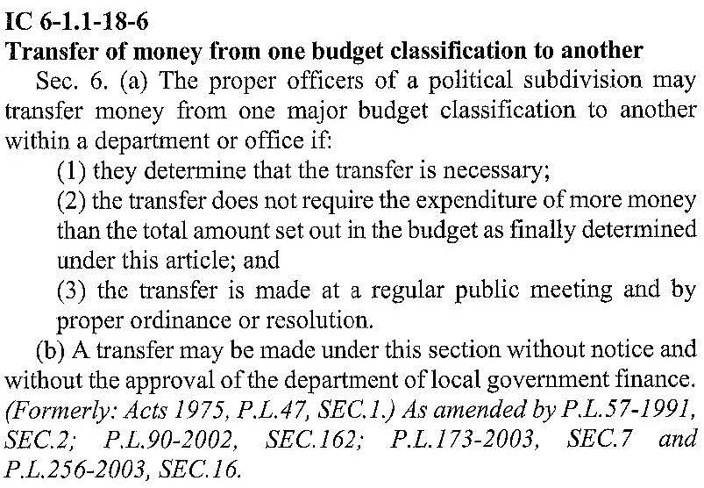
NOW THEREFORE, BE IT RESOLVED by the Common Council of the City of Woodburn:
That within the GENERAL FUND, the following lines are debited as described:
101-000-000245 UTILITY 3 WAGE, in the amount of $1,000.00
101-001-000312 LEGAL CLERK-TREASURER, in the amount of $1,500.00
101-001-000351 ELECTRIC TILE MILL, in the amount of $5,000.00
101-002-000117 PART TIME OFFICER, in the amount of $4,000.00
101-002-000119 FULL TIME OFFICER, in the amount of $10,000.00
101-002-000121 77 FUND, in the amount of $1,500.00
101-002-000221 FUEL POLICE DEPT., in the amount of $5,000.00
101-002-000320 CELL PHONE/AIR CARDS, in the amount of $500.00
Total Debit: $28,500.00
And, within the GENERAL FUND, the following lines are credited as described:
101-001-000211 OFFICE SUPPLIES, in the amount of $2,500.00
101-001-000350 ELECTRIC CITY HALL, in the amount of $500.00
101-001-000393 PROMOTIONS, in the amount of $500.00
101-001-000430 COMPUTER HARDWARE/SOFTWARE, in the amount of $10,000.00
101-001-000442 IT SERVICES, in the amount of $2,500.00
101-002-000213 OFFICE SUPPLIES, in the amount of $500.00
101-002-000240 OTHER SUPPLIES, in the amount of $1,000.00
101-002-000354 TELEPHONE POLICE, in the amount of $250.00
101-002-000355 ELECTRIC POLICE DEPARTMENT, in the amount of $500.00
101-002-000356 GAS POLICE DEPARTMENT, in the amount of $250.00
101-002-000397 OTHER EQUIPMENT, in the amount of $10,000.00
Total Credit: $28,500.00
This appropriation transfer will result in a net transfer of $0.00 within the GENERAL FUND.

That within the COIT PUBLIC SAFETY FUND, the following line is debited as described:
247-000-000313 LEGAL FEES POLICE DEPARTMENT, in the amount of $750.00
Total Debit: $750.00
And, within the COIT PUBLIC SAFETY FUND, the following line is credited as described:
247-000-000135 PD MISC, in the amount of $750.00
Total Credit: $750.00
This appropriation transfer will result in a net transfer of $0.00 within the COIT PUBLIC SAFETY FUND.

That within the EDIT FUND, the following line is debited as described:
444-000-020000 HICKORY STREET, in the amount of $50,000.00
Total Debit: $50,000.00
And, within the EDIT FUND, the following lines are credited as described:
444-001-000301 PROFESSIONAL SERVICES, in the amount of $25,000.00
444-001-039901 MISC, in the amount of $25,000.00
Total Credit: $50,000.00
This appropriation transfer will result in a net transfer of $0.00 within the EDIT FUND.

In accordance with previous reporting to DLGF, the following reductions will also occur:
MVH 201-000-020000 HICKORY STREET CONSTRUCTION FOR $170,000.00
201-000-200000 TRANSFERS TO OTHER FUNDS FOR $30,000.00
LR & S 202-000-020000 HICKORY STREET CONSTRUCTION FOR $30,000.00
RAINY DAY 245-000-020000 HICKORY STREET CONSTRUCTION FOR $50,000.00

Adopted and Resolved this 16th day of November, 2020.
< SIGNATURES ON THE FOLLOWING PAGE >
COMMON COUNCIL OF THE CITY OF WOODBURN, INDIANA

By: ___________________________________ YEA_____ NAY_____ ABS_____
Michael Voirol, Councilman

By: ___________________________________ YEA_____ NAY_____ ABS_____
Michael Martin, Councilman

By: ___________________________________ YEA_____ NAY_____ ABS_____
Tonya Thompson, Councilman

By: ___________________________________ YEA_____ NAY_____ ABS_____
Dean Gerig, Councilman

By: ___________________________________ YEA_____ NAY_____ ABS_____
Daniel Watts, Councilman

ATTEST:

By: ______________________________________
Timothy Cummins, Clerk-Treasurer

The foregoing resolution passed by the Council is signed and approved ( ) / not approved ( ) by me on the same date.

By: ____________________________________________
Joseph Kelsey, Mayor for the City of Woodburn

